Task 1: Deploy a Sales prediction ML Application with CI/CD Pipeline using GitHub, CloudBuild and CloudRun

**Step 1**: Train and export a simple ML Model

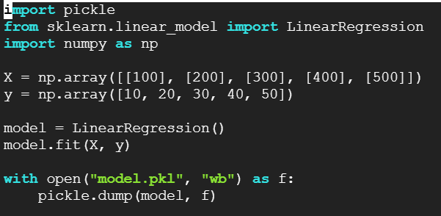

**Step 2:** Create a Flask app with a /predict endpoint

**Step 3:** Containerize the app using a Dockerfile

**Step 4:** Create a cloudbuild.yaml to build and deploy the app using CloudBuild and CloudRun

**Step 5:** GitHub Repository setup and GCP Integration

**Step 6:** Create Cloud Build Trigger in Google Cloud

**Step 7:** Trigger Testing

